

**SCHOOL OF ENGINEERING and PHYSICAL SCIENCES**

**ELECTRICAL AND ELECTRONIC ENGINEERING**

|  |  |  |
| --- | --- | --- |
| **No.** | **HWUM ID** | **Name of Group Members** |
| 1 |  |  |
| 2 |  |  |
| 3 |  |  |

|  |  |  |
| --- | --- | --- |
| **Campus and Lecturer** |  | |
| **Date** | **Due Date:** | **Submitted Date:** |

|  |  |
| --- | --- |
| **Lab Sheet No.** |  |
| **Title of Lab Sheet** |  |

|  |  |
| --- | --- |
| **Lab Report Item / total marks** | **Marks** |
| Lab Report (Results and  Discussions) / 20 |  |
| Format (incl. all or some of the  following: Abstract, Introduction and Theory, Figures and Diagrams,  Conclusions) /5 |  |
| Total / 25 |  |

Table of Contents

|  |  |  |
| --- | --- | --- |
|  | Abstract |  |
|  | Introduction |  |
|  | Experiment Design |  |
|  | Materials |  |
|  | Methods |  |
|  | Procedure |  |
|  | Results & Discussion |  |
|  | Tables |  |
|  | Graphs |  |
|  | Analysis |  |
|  | Guidelines for error analysis |  |
|  | Definitions |  |
|  | Conclusions & Recommendations |  |
|  | References |  |
|  | Appendix |  |
|  | Safety Guidelines |  |

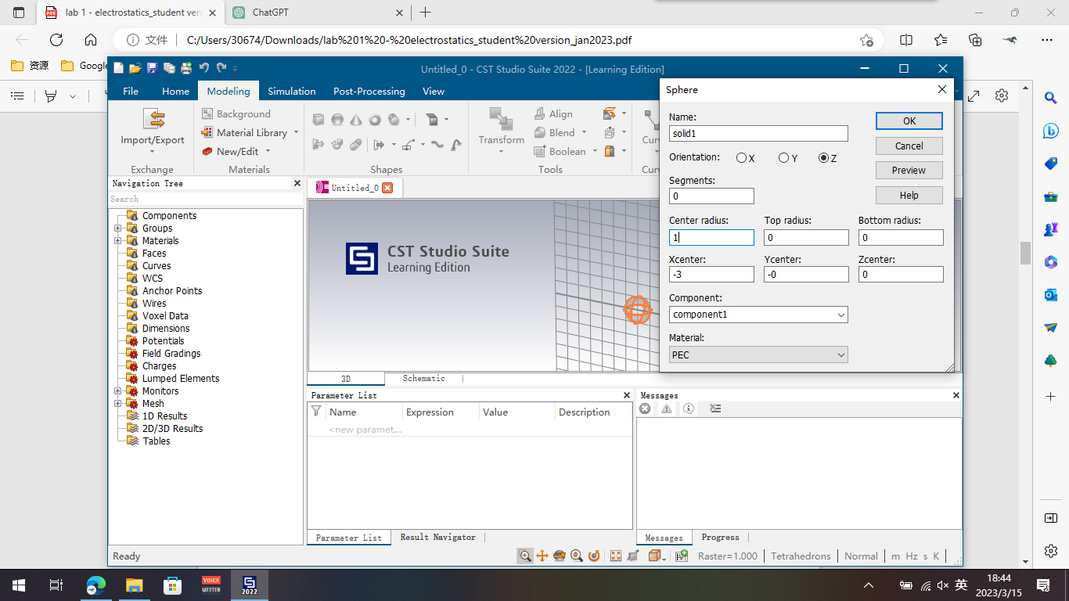

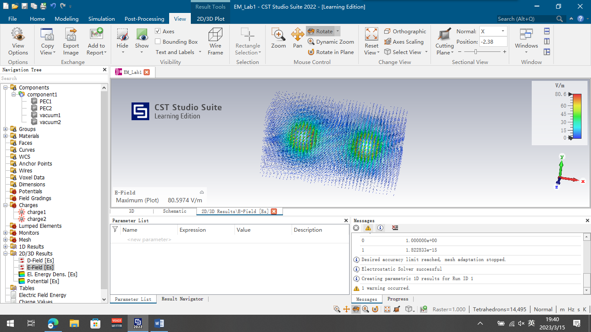

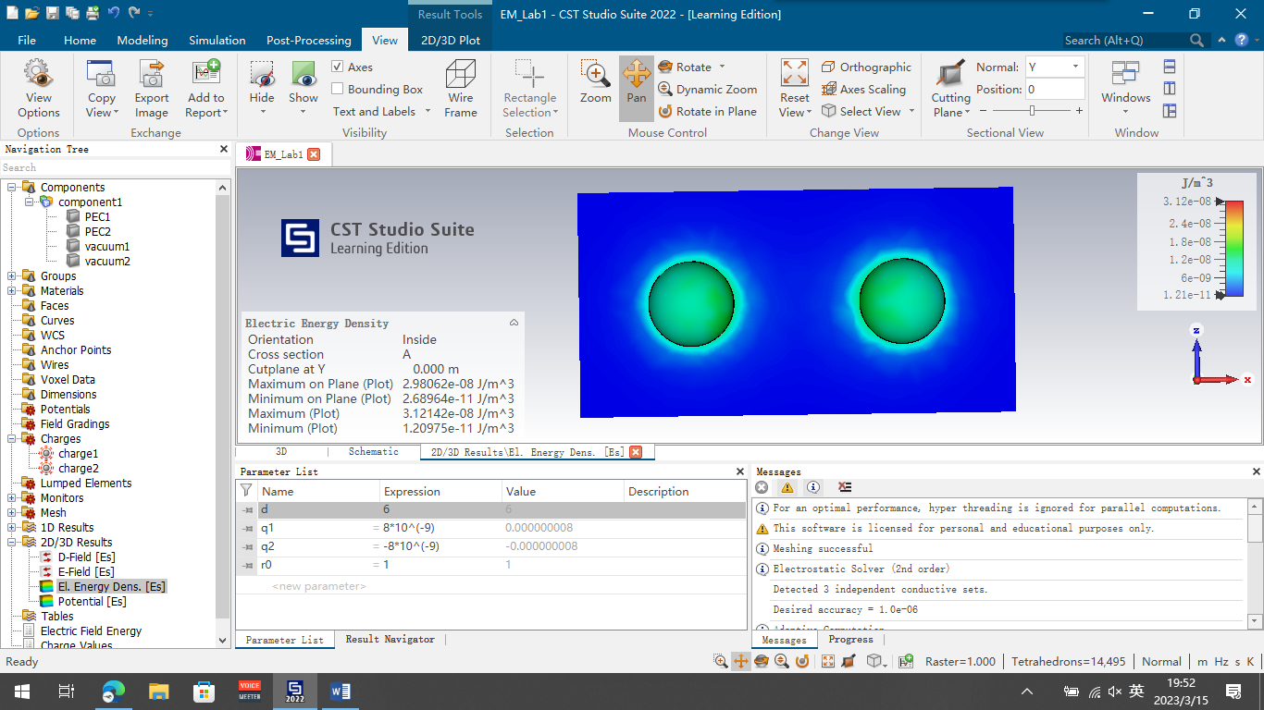

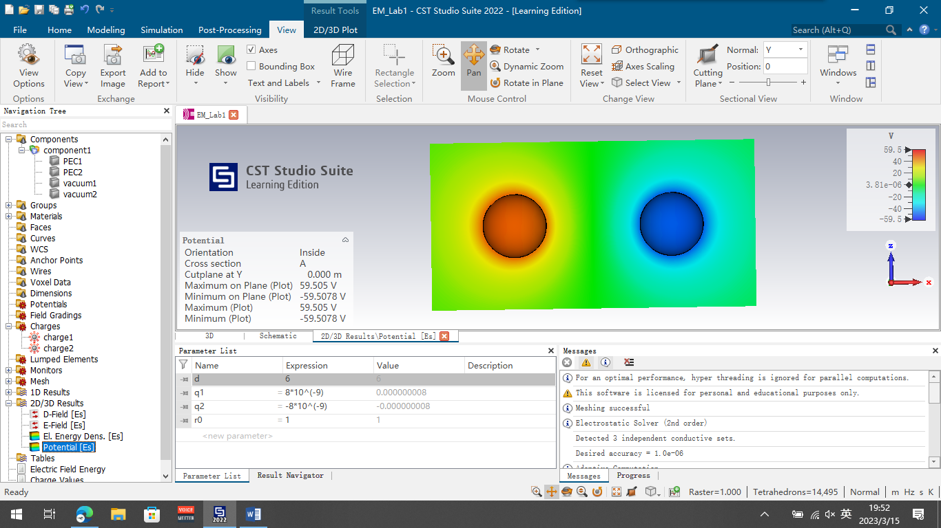

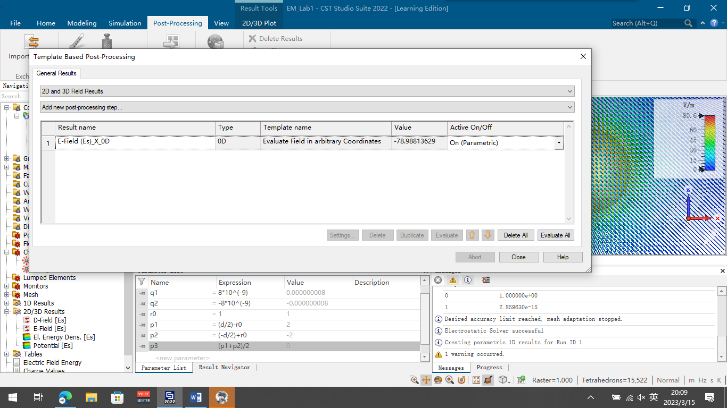

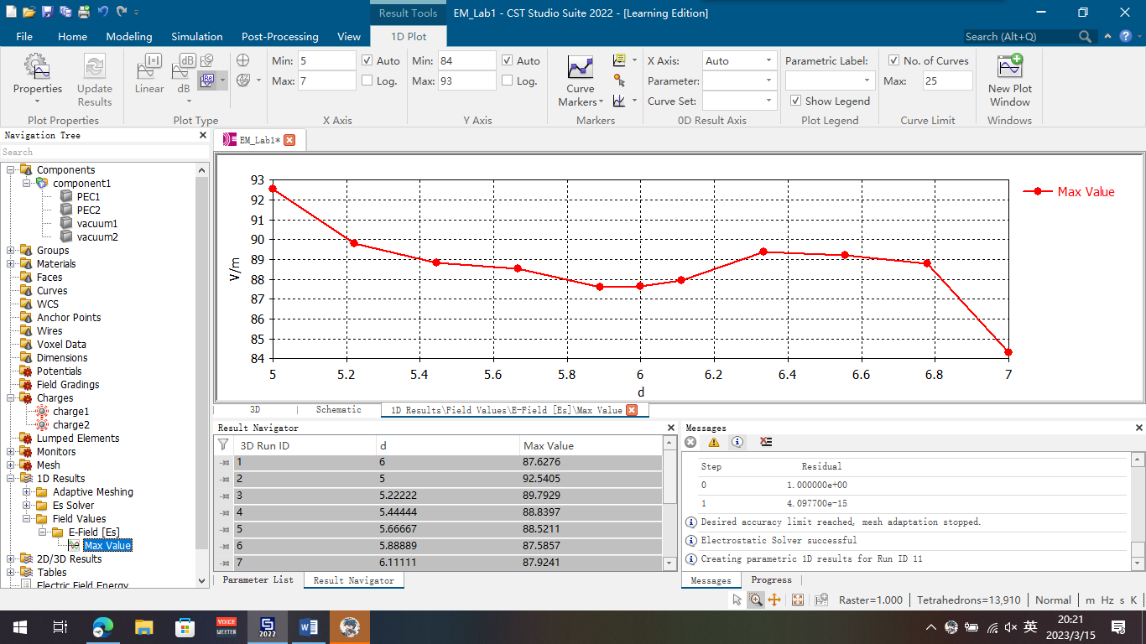

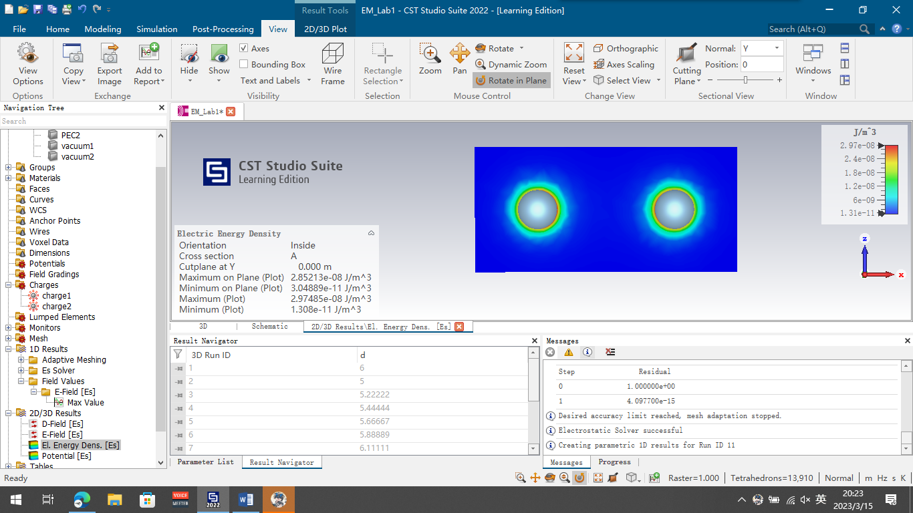

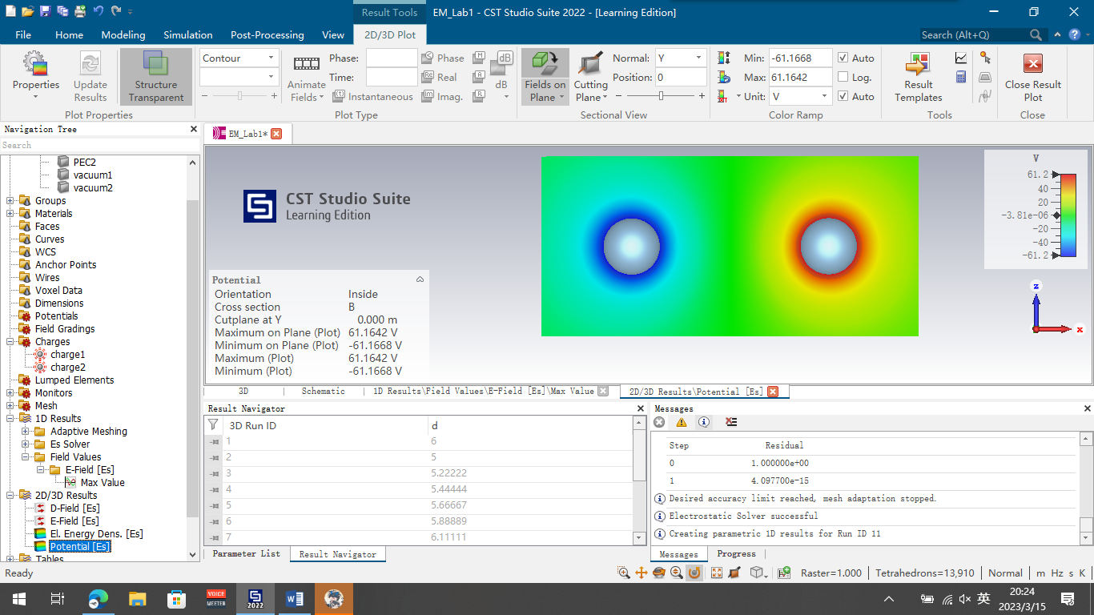

# **ABSTRACT**

This manual is intended to provide the general instructions for preparing a laboratory report. It can be used as a template for writing the report with Word 6.0 and later. For other document- editors, use the guidelines provided in this manual. The major aim of the abstract is to provide a concise summary of the entire report and present upfront the major conclusions derived from the experimental investigations. It is advisable to create the abstract after writing the final draft of the report.

**INTRODUCTION**

The major goal of a laboratory report is to record a factual and accurate account of an experimental investigation. This document serves as a template for creating such a report using Microsoft *Word* 6.0 or later. It is important for the laboratory report to be (i) Concise (ii) Objective (iii) Technical and (iv) Accurate. Preparation of a lab report involves a continuous iterative process of collecting data and performing analysis on the measurements. The process may be further divided into four phases

1. Pre-Lab **–** Where students prepare for the lab by collecting some basic information needed for the experiments
2. In-Lab **–** When students collect and organize data from observations made during the lab
3. Post-Lab **–** The phase in which the measured data is analyzed and aggregated into graphs, charts and tables and
4. Lab-Check **–** Final phase where the lab report is compiled and the conclusions from the experiments are derived.

The introduction section of the laboratory report must clearly state the objective of the experiment and provide the reader with all the necessary background. It should concisely provide the scientific theory behind the experiment and equip the reader with the basic background needed to understand the experiments discussed in the laboratory report. The margins should be 2.5cm (top), 2.5 cm (bottom), 3.0 cm left, and 2.5 right, respectively [1].

# **EXPERIMENT DESIGN (FIGURES AND DIAGRAMS)**

The laboratory report must capture all the information necessary to repeat the experiments in the future. It is therefore important to record an accurate description of the experiment design including the apparatus used, methods for gathering data and control procedure followed during the experiment.

## **MATERIALS**

Present the experiment setup with appropriate level of detail. Illustrations may be used wherever necessary to clearly depict the apparatus used for the experiments. It is advisable to use past tense and consistent voice (either active or passive) throughout the entire report.

Title

References

Appendix

Safety Guidelines

……..

Abstract

Introduction

Experiment Design

Results

Analysis

Conclusion&Recommendations

References

Appendix

Safety Guidelines

Figure 1. General Structure of a Laboratory Report

**METHODS**

Describe the methods used to collect the data from the experiment. Make a note of the standard errors, in order to capture the accuracy of the collected data points. Clearly explain the procedure needed to calibrate the measurements. Any deviations from the standard methods should be clearly mentioned in the report. The major objective here is to clearly explain how the data was collected and understand the limitations of the collected data.

## **2.3.Procedure**

The process used to control the experiment is described here. Provide appropriate level of detail in this section. Avoid lengthy descriptions for standard procedures and those provided in lab manuals.

# **RESULT AND DISCUSSION**

This section should record all the information collected as a part of the experiment. In addition to the collected data, it must also contain information read directly from the laboratory instruments and specifications presented in instrument manuals. Do not attempt to hide faulty data. Information from suspected erroneous data points helps understand the behavior of the system under different conditions and enables a post-lab analysis of problems with the experiment. It is important to organize the quantitative information into tables and charts, with appropriate units. The scale of the data should be chosen appropriately and significant figures should be used for the measurements whenever possible.

## **3.1.Tables**

Collected data can be presented in a table, whenever one or more columns of the data are in series. Presenting information in a tabular format allows the reader to quickly access the major results of the experiment. Prudent judgment of the amount of information to be presented in tables is very important. The headings of the tables must be in bold and the units of the data points must be clearly mentioned. Use serial numbers to make reference to any measurements presented in the table.

Table 1. Font Size for different document elements

|  |  |  |
| --- | --- | --- |
| **S.No** | **Document Element** | **Font-Size (pts)** |
| 1 | Title | 14 |
| 2 | Abstract | 12 |
| 3 | Section Headings | 12 |
| 4 | General Text | 12 |

## **3.2.Graphs**

A line graph is used to show continuing data; how one thing is affected by another. It's clear to see how things are going by the rises and falls a line graph shows. This kind of graph is needed to show the effect of an independent variable on a dependent variable. In the sample below, the pulse rate of a person is shown to change over time. As time continues, the pulse rate changes.

A typical chart or table for this graph might look like this (label the graph number also)

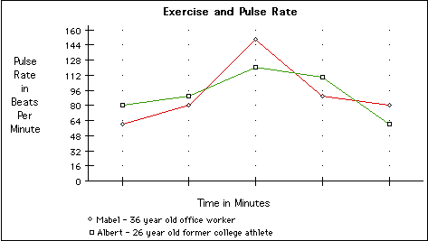

Figure : 2 Line Graph Example

# **4.0 ANALYSIS**

Analyze the information collected during the experiment and present the key observations in this section. Include all the equations showing your calculations. In the case of repetitive calculations, it is sufficient to provide the details for just one sample data point. Make references to the value in the tables and graphs in the previous sections. For example Table 1shows the different font values that need to be used in different sections of the report.

Comparison of the measured results with theoretical values is useful. Describe the nature of the errors and possible methods to overcome the inaccuracies of the experiment. In the case of systematic errors like inaccurate equipment, the solution may be to calibrate the system further, whereas for random errors taking multiple measurements may lead to more accurate results. Perform error analysis and compute the relative error of the measured values.

## **4.1Guidelines for error analysis**

1. Human error is usually not a valid error to be captured in error analysis. Repeating the experiment is mandatory whenever human error is involved.
2. Comparison with experimental results obtained by others is not very useful. It may not indicate the actual error in the observed values. Error analysis must be performed independently and compared with the theoretical values.
3. High-level error analysis techniques must be used wherever possible. Do not use fancy error measurement techniques as these may not be appropriate for the scope of the laboratory report.

## **4.2 Definitions**

1. Precision **–** The smallest change that can be recorded by the experiment setup.
2. Accuracy **–** Measure of the correctness of the experimental results.

**5.0 CONCLUSIONS AND RECOMMENDATIONS**

Conclude your report by presenting answers to the problems you have stated in the introduction. Base your conclusions on the analysis presented in the previous section and use this to reaffirm the stated results in the abstract. Understand that the conclusions from one experiment form basis to perform future experiments. Show an awareness of the limitations of the experiment and explain the rationale behind the generalizations from the results. Clearly explain any ambiguities or complications encountered during the experiment as this is very useful in modifying the experiments in the future.

Suggest possible improvements to the experiment and describe these enhancements in detail. Restate the problem under investigation and conclude with a condensed summary of the solution obtained from the experimental investigation.

# **REFERENCES**

Use square brackets to number the citations like [1]. Make sure that any punctuation marks are placed after the citation. When citing multiple references use separate square brackets.

Make sure that the page numbers are listed at the end of the reference, especially when citing materials from books and journals. The purpose of a citation is to allow the reader to explore further and understand where the particular idea originated. Providing all the references used for the experiment is very important for a comprehensive report.

It is not necessary to cite all the references in the report, some of them may be general references and not pertain to any specific part of the report.

Scientific lab reports are written for the sole purpose of sharing information. If readers want more information about something, they need to be able to find the exact place it was originally written. References also give credit to the person who did the work and provide your work with authority.

1. Lakshmanan Singaram, “Preparation of Laboratory Reports”, TU Publication, 2007.

**APPENDIX**

Present any additional information regarding the report in a separate appendix section. This allows the reader to avoid having to understand the complete details before obtaining an overview of the experiment. This section can contain any raw data and tabulations, which support the argument made in the report but are not necessary for the core objectives. Include pictures detailing the experimental setup, tools used etc.